**Orthodox Christmas**

*Many Orthodox Christians annually celebrate Christmas Day on or near January 7 to remember Jesus Christ’s birth, described in the Christian Bible. This date works to the*[*Julian calendar*](https://www.timeanddate.com/calendar/julian-calendar.html)*that pre-dates the*[*Gregorian calendar*](https://www.timeanddate.com/calendar/gregorian-calendar.html)*, which is commonly observed.*

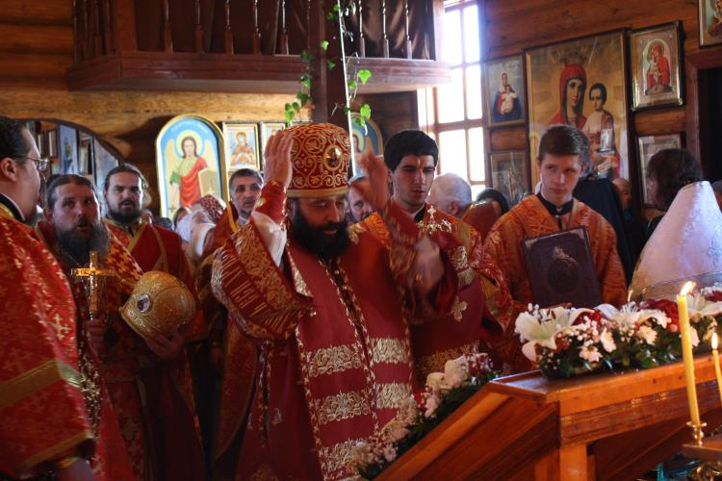

Some Orthodox Christians visit a church to pray or reflect on inner thoughts in the lead up to the Orthodox Christmas Day.

**What Do People Do?**

Orthodox Christians in central and eastern Europe and other parts of the world celebrate Christmas on January 7. The Christmas dates around January 7 may vary among some churches. The day is a time of reflection, inner thoughts and healing in many eastern European countries. Many Orthodox Christians fast before January 7, usually excluding meat and dairy products. Foods may include:

* Lenten bread.
* Nuts and fresh dried fruits.
* Vegetables and herbs such as potatoes, peas, and garlic.
* Mushroom soup.
* Slow-cooked kidney beans with potatoes, garlic, and seasoning.
* *Bobal’ki* (small biscuits combined with sauerkraut or poppy seed with honey).
* Honey.
* Baked cod.

Christmas Day, on the other hand, is a day for feasting and enjoying the company of friends and family members. The Christmas meal usually includes meat and different types of pastries. One traditional Russian Christmas dish is baked goose with apples.

The type of food and activity may vary depending on the country’s culture and traditions. In some Orthodox Christian cultures, people walk in procession to seas, rivers and lakes as part of the liturgy on the Orthodox Christmas Day. They make holes in the ice to bless the water if it is frozen. Little importance is given to gift exchanges and the commercialized Christmas.

Some Orthodox Christians observe the Nativity and Adoration of the Shepherds (those who visited baby Jesus) on January 6, followed by the Adoration of the Magi (three wise men or kings) on January 7. Church liturgies on Orthodox Christmas Eve (January 6) may be longer than usual but many people find them inspiring.

**Public Life**

Christmas Day is a public holiday on January 7 in countries such as Belarus, Egypt, Ethiopia, Georgia, Kazakhstan, Macedonia, Moldova, Montenegro, Serbia, Russia, and Ukraine. Some countries, such as Armenia, observe Christmas Day on January 6. The January 7 celebration of Christmas Day is not a nationwide public holiday in countries such as [Australia](https://www.timeanddate.com/holidays/australia/orthodox-christmas-day), [Canada](https://www.timeanddate.com/holidays/canada/orthodox-christmas-day), [the United Kingdom](https://www.timeanddate.com/holidays/uk/orthodox-christmas-day) or [the United States](https://www.timeanddate.com/holidays/us/orthodox-christmas-day).